Internship in Purchasing: Maintenance of Supplier Library

We are Melcom.Tech (https://melcom.tech/) a German trading company. We help our European customers to by all sorts of technical components in China. Melcom.Tech is a business unit of the Melchers Group.

Melchers Group (https://www.melchers.de/cn/profil/zahlen-fakten/)
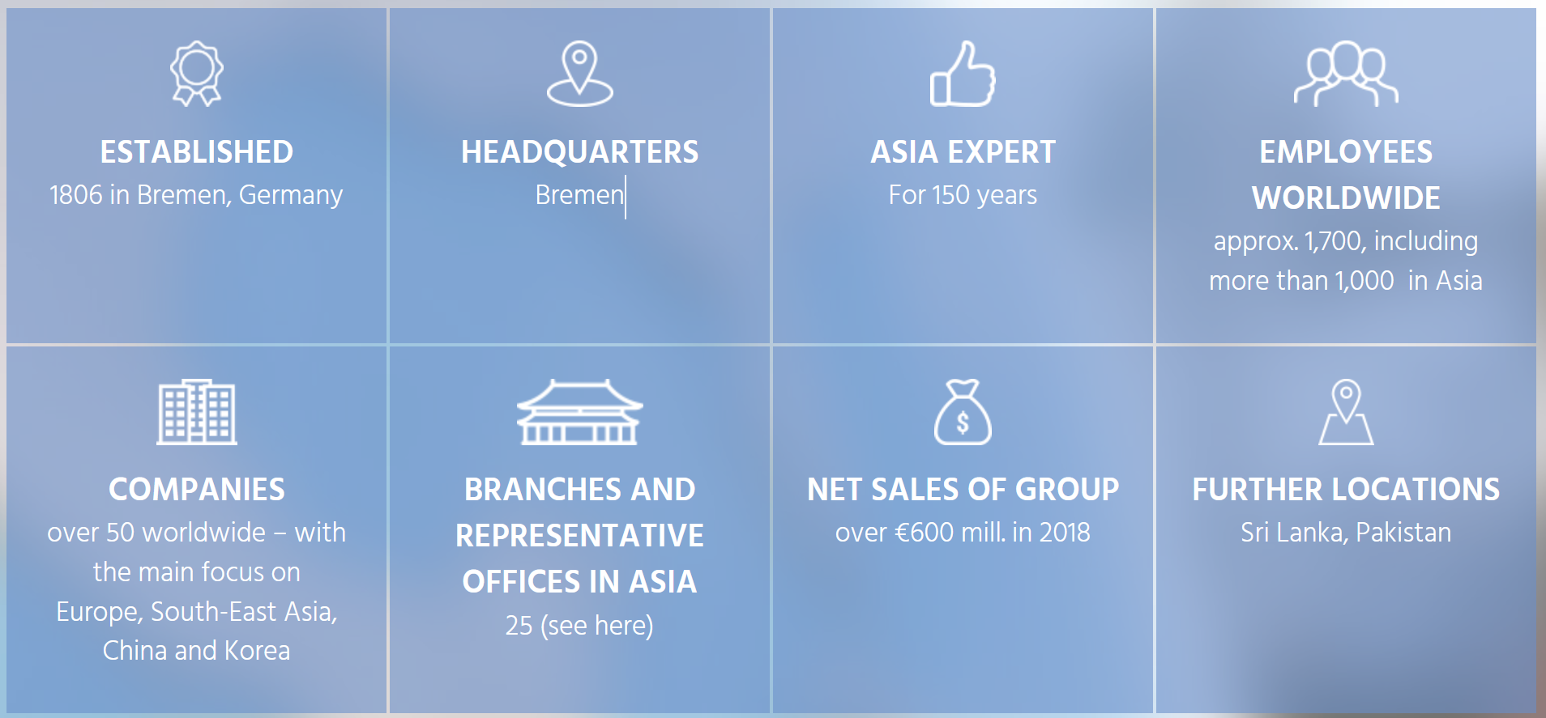

Internship description:
Melcom China is seeking a motivated intern for our purchasing department. Your focus would be to helps us maintain our supplier library and expand its scope and depth. The result should be an improve and up to date supplier library of existing supplier but also potential new suppliers.

Scope of work:
- Evaluate structure of the existing supplier library and improve classification (like production method, product range, offered material.)
- Update supplier questionnaire based on new supplier library structure
- Consolidate the existing supplier databases
- Closely work together with our purchasing staff to get all relevant historical supplier data
- Help the team to update new suppliers
- Help to expand our supplier base by searching for new potential suppliers, evaluate them and add them to our list
- Check with suppliers about the production capabilities and the areas where they have a competitive advantage. Record in our supplier library.

Requirements:
- Technical background (Mechanical engineer, Industrial engineer etc.), Understanding of basic production technologies and their classification
- Good excel skills
- Good communication skill, not shy to cold call suppliers
- Fluent Chinese, Good in English, German would be an advantage

Other:
- 130 RMB Salary per full working day
- Full time
- Preferred duration around 6 Month
- Start: earliest possible date
- Location Shanghai (People Square)

Contact:
Please directly send your CV and Cover to Moritz Koehler (Koehler@sh.melchers.com.cn), Purchasing Manger Melcom.tech

